Image Denoising with a
Convolutional Autoencoder
A Deep Learning Project on the MNIST Dataset

Theory, Architecture, Implementation & Results

Contents

1. Introduction
This project builds a deep learning model that removes noise from images. The model is a convolutional autoencoder trained on the MNIST dataset of handwritten digits. The task — called image denoising — is to take a corrupted image as input and produce a clean version as output.
The central idea is simple but powerful: we deliberately add random noise to clean images, then ask a neural network to recover the originals. Because the network is forced to undo the corruption, it must learn the underlying structure of what a digit looks like, rather than simply copying pixels.
Why MNIST? MNIST contains 70,000 grayscale images of handwritten digits (0–9), each 28×28 pixels. It is small, clean, and well understood, which makes it ideal for demonstrating the denoising concept without needing large compute resources.

2. Theory

2.1 What is an Autoencoder?
An autoencoder is a neural network that is trained to copy its input to its output. That sounds trivial, but the trick is that the network is forced to pass the information through a narrow bottleneck in the middle. It has two halves:
- Encoder — compresses the input image into a small, dense representation called the latent code (or bottleneck). This forces the network to keep only the most important information.
- Decoder — takes the latent code and reconstructs a full-size image from it.
Formally, the encoder is a function f that maps an input x to a latent code z = f(x), and the decoder g maps the code back to a reconstruction x̂ = g(z) = g(f(x)). Training adjusts f and g so that x̂ is as close as possible to x.
Because the bottleneck is smaller than the input, the network cannot simply memorise every pixel. It must discover an efficient, compressed description of the data — much like learning the concept of a digit instead of a specific image.

2.2 From Autoencoder to Denoising Autoencoder
A denoising autoencoder (DAE) makes one key change. Instead of feeding the clean image as input, we feed a corrupted version, but still ask the network to reconstruct the clean original. The corruption is applied on the fly:
x̃ = x + n, where n ~ 𝒩(0, σ²)
Here x is the clean image, n is random Gaussian noise with standard deviation σ, and x̃ is the noisy image. The network sees only x̃ and must output something close to x. Learning to reverse the corruption prevents the trivial identity solution and pushes the network toward genuinely understanding the data's structure.

2.3 The Loss Function
We measure reconstruction quality with the Mean Squared Error (MSE) between the reconstruction and the clean target, averaged over all N pixels:
MSE = (1/N) Σ ( x_{i} − x̂_{i} )²
Minimising MSE drives every output pixel toward its clean target value. Gradients of this loss are propagated back through the decoder and encoder using backpropagation, and the weights are updated with the Adam optimiser.

2.4 Why Convolutions?
Images have strong local structure: nearby pixels are highly correlated, and the same visual patterns (edges, curves, strokes) appear all over the image. Convolutional layers exploit this with two properties:
- Local connectivity — each filter looks at a small patch, matching the local nature of image features.
- Weight sharing — the same filter slides across the whole image, so a feature can be detected anywhere with far fewer parameters than a fully-connected layer.
In the encoder, strided convolutions shrink the spatial size while increasing the number of feature channels. In the decoder, transposed convolutions do the reverse, enlarging the feature maps back to the original resolution.

2.5 Measuring Success: PSNR
Beyond the raw loss, denoising quality is commonly reported with the Peak Signal-to-Noise Ratio (PSNR), measured in decibels (dB). For images scaled to the range [0, 1]:
PSNR = 10 · log₁₀( 1 / MSE )
Higher PSNR means the reconstruction is closer to the original. Each increase of a few dB represents a clearly visible improvement in quality. We use PSNR to compare the noisy input against the clean target (a low baseline) and the denoised output against the clean target (which should be much higher).

3. Dataset and Noise Model
The dataset is MNIST stored as PNG images, organised into folders by digit:
- Training set: 60,000 images (a subset of 20,000 is used here for fast CPU training).
- Test set: 10,000 images (a subset of 2,000 is used for evaluation).
- Each image is grayscale, 28×28 pixels, with values scaled from 0–255 to the range [0, 1].
Gaussian noise with standard deviation σ = 0.5 is added to each image, and the result is clipped back to [0, 1]. At this noise level the digits are heavily obscured, making the task genuinely challenging.

4. Model Architecture
The model is a compact fully-convolutional autoencoder with roughly 37,500 trainable parameters. The encoder halves the spatial resolution twice (28 → 14 → 7) while growing the channel count, and the decoder mirrors this to rebuild the image.
Layer | Output shape | Operation | Role
Input | 1 x 28 x 28 | noisy image | —
Conv2d + ReLU | 32 x 14 x 14 | stride-2 conv | Encoder
Conv2d + ReLU | 64 x 7 x 7 | stride-2 conv | Bottleneck
ConvTranspose2d + ReLU | 32 x 14 x 14 | upsample | Decoder
ConvTranspose2d + Sigmoid | 1 x 28 x 28 | upsample | Output

The final Sigmoid activation squeezes every output pixel into [0, 1], matching the range of the clean target images.

5. Training Procedure
Training follows the standard supervised loop, with the twist that inputs and targets differ only by the added noise:
- Load a batch of clean images and scale them to [0, 1].
- Add fresh Gaussian noise to create the corrupted inputs.
- Pass the noisy images through the autoencoder to get reconstructions.
- Compute the MSE loss between reconstructions and the clean images.
- Backpropagate and update the weights with the Adam optimiser.
- After each epoch, evaluate MSE and PSNR on the held-out test set.

Key hyperparameters: optimiser = Adam, learning rate = 1e-3, batch size = 128, epochs = 12, noise σ = 0.5.

6. Results
The model trained smoothly. Both training and test loss fell quickly and then converged, staying close together — a sign that the model generalises well and is not overfitting. Test PSNR rose steadily across epochs.
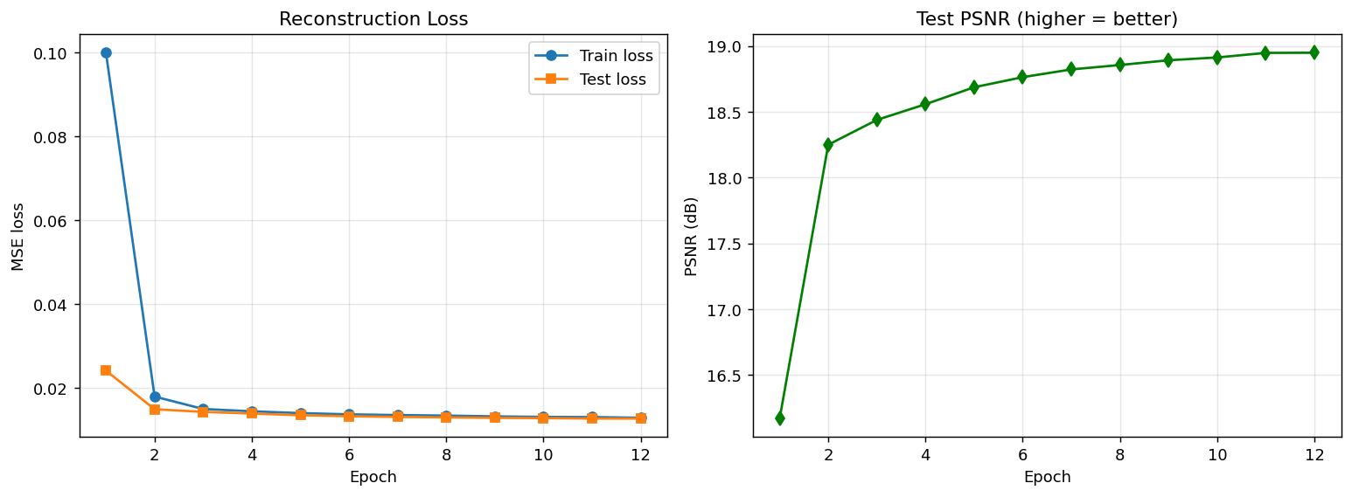
Figure 1: Reconstruction loss (left) and test PSNR (right) over 12 epochs.
The qualitative results are striking. The top row below shows the noisy inputs — at σ = 0.5 the digits are barely recognisable. The middle row shows the model's denoised output, and the bottom row shows the clean targets. The reconstructions are clean and legible across all ten digit classes.
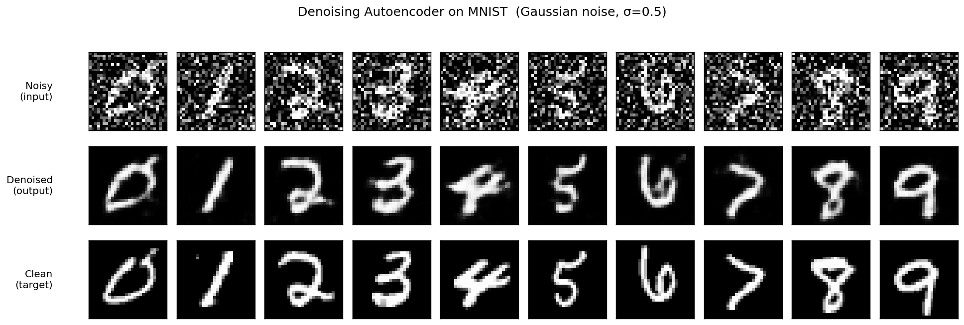
Figure 2: Noisy input (top), denoised output (middle), and clean target (bottom).
Numerically, the improvement is large. The denoiser nearly doubles the PSNR compared with the noisy input:
Image | PSNR vs clean (dB) | Interpretation
Noisy input | 9.36 | Heavily corrupted
Denoised output | 18.95 | Clean, legible
Improvement | +9.59 | ~2x higher PSNR

An improvement of +9.59 dB confirms that the network learned a genuine denoising function rather than a trivial copy.

7. Conclusion and Extensions
This project demonstrated the full pipeline of a denoising autoencoder: corrupting clean MNIST digits with Gaussian noise, training a convolutional encoder–decoder to reverse the corruption, and evaluating the result both visually and with PSNR. Despite its small size, the model removed heavy noise and reconstructed clear, recognisable digits.
Several natural extensions could push the results further:
- Train on all 60,000 images and for more epochs for higher final PSNR.
- Add skip connections (a U-Net style architecture) to preserve fine details.
- Experiment with other noise types, such as salt-and-pepper or speckle noise.
- Try a denoising objective on more complex datasets (Fashion-MNIST, CIFAR-10).
- Compare against classical denoisers such as Gaussian blur or median filtering.

Files in this project: train_denoiser.py (training), visualize.py (figures), denoiser.pth (trained weights), and this report.

